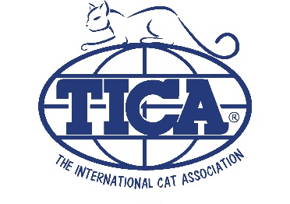
Dr. Elsey’s Show Sponsorship Funds
Available to All TICA Licensed Clubs

Looking to host a show, but short on funds? To help ease the cost of hosting shows, all TICA licensed clubs are eligible to apply for Dr. Elsey's Club Sponsorship funding. This program has been in place for several years, don’t miss out.

Allocations for 2023 shows include:

- Each club may receive $500 per club per calendar year.
- Clubs are eligible to receive $750 for hosting a Regional Show. Please note, Regional Shows do not count as the $500 annual club allocation.
- Clubs may receive $1,000 per club for hosting Pet Expos.

To apply for Dr. Elsey’s club sponsorship funds, each club must:

- Complete a Club Show Sponsorship Form. The completed form must be eMailed a minimum 60 days in advance of show date. to ShowSponsorship@tica.org.
- Show information must be listed in the TICA show calendar on tica.org prior to applying for funds. Please note, TOES does not do this automatically. (I want to make sur this is still correct, or does the TFMS/TOES integration do this automatically).
- Clubs outside North America must provide a PayPal account in the name of the club to receive payment. You will also be asked if Dr. Elsey’s litter products are available in your area.

